ADMIN

Admin before login

Admin after login

Admin-animal-before editing anything

admin-animal- add

admin-animal-delete

admin-owner-before doing anything  
admin-owner-add

Amin-owner-edit

Admin-owner-delete

Admin-appointments- before

admin-appointments-create

admin-appointments-delete

Appointments-cancelation

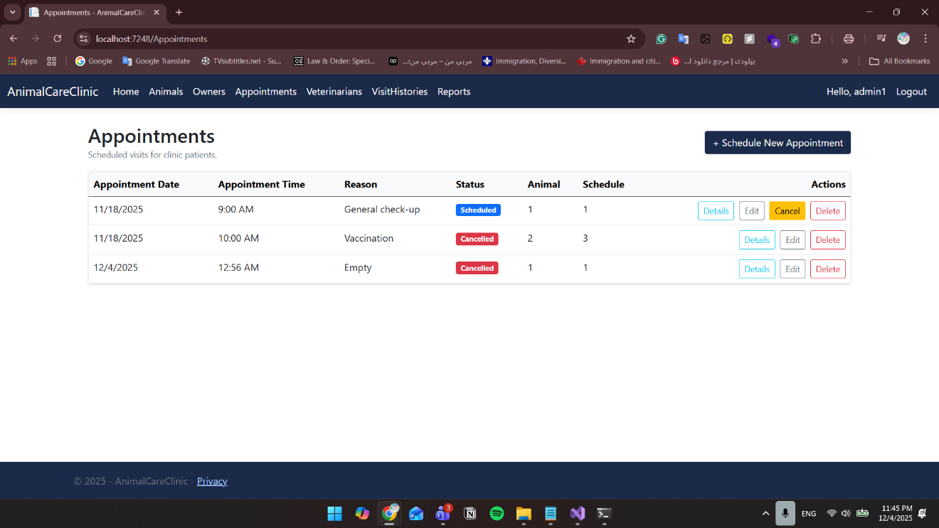

Admin-vet-before  
  
admin-vet-edit

admin-vet-add

Admin-visitHistory-add

Admin-history-delete

Admin-reports-before

Admin-reports-after adding an appointment

